ASSIGNMENT NO.5
2124UCEF1085
- INTRODUCTION
Application Redirection: Write a program that allows users to navigate from one application to another. For example, implement a feature that redirects users to a map application when they click on a "View Location" button, passing the destination address for navigation.
- TOOLS & TECHNOLOGIES USED
Android Studio Language: (JAVA) ,
Open Android Studio and create a new project,
Emulator or Physical Device (Android API 35).

- PROCEDURE & STEPS
Step:1 -Create a New Project
-Choose Bottom Navigation Activity template.
-Set the project name and package name.
-Select the programming language(JAVA). 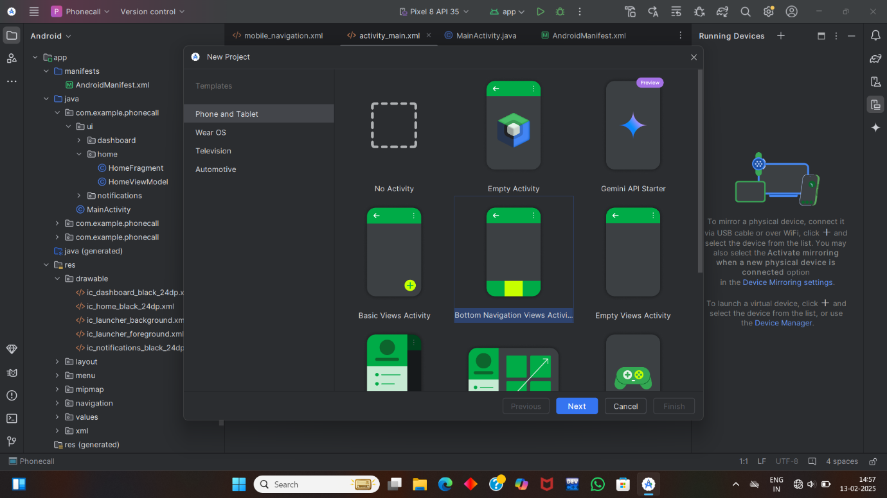
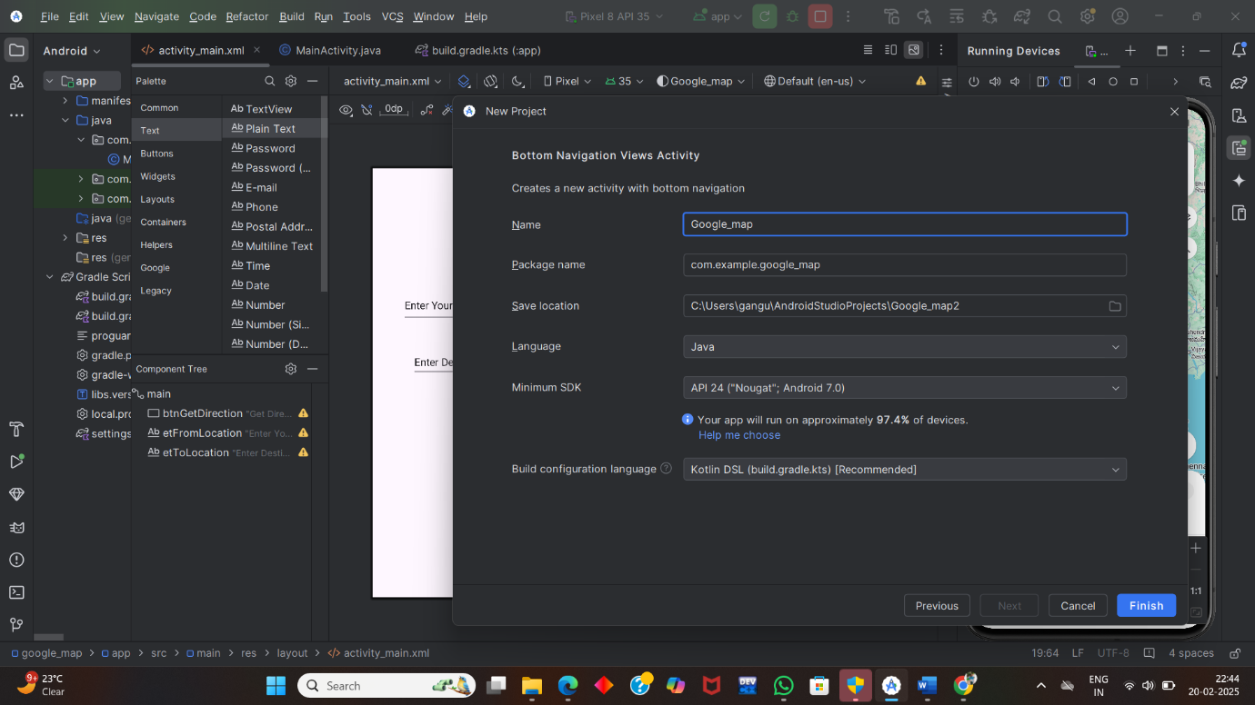

Step 2: Designing the UI
Open activity_main.xml and design the layout using XML.
Add UI components such as input Field for user to input a location and Destination.
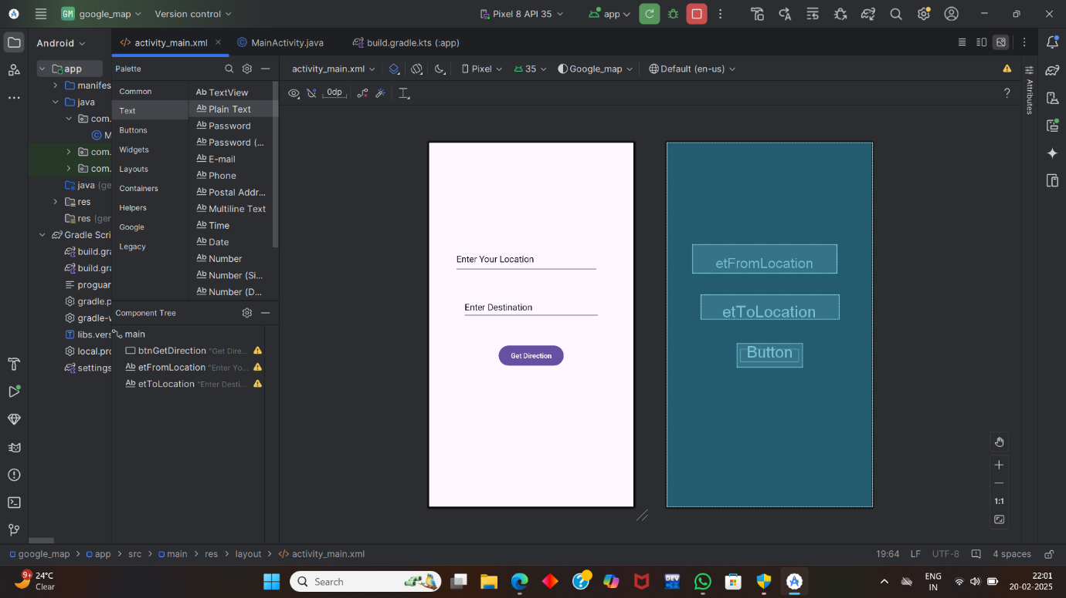
Step 3: Writing the code:
activity_main.xml:
<?xml version="1.0" encoding="utf-8"?>
<androidx.constraintlayout.widget.ConstraintLayout xmlns:android="http://schemas.android.com/apk/res/android"
xmlns:app="http://schemas.android.com/apk/res-auto"
xmlns:tools="http://schemas.android.com/tools"
android:id="@+id/main"
android:layout_width="match_parent"
android:layout_height="match_parent"
tools:context=".MainActivity">
<Button
android:id="@+id/btnGetDirection"
android:layout_width="wrap_content"
android:layout_height="wrap_content"
android:layout_marginBottom="280dp"
android:text="Get Direction"
app:layout_constraintBottom_toBottomOf="parent"
app:layout_constraintEnd_toEndOf="parent"
app:layout_constraintStart_toStartOf="parent"
app:layout_constraintTop_toBottomOf="@+id/etToLocation"
app:layout_constraintVertical_bias="1.0" />
<EditText
android:id="@+id/etFromLocation"
android:layout_width="289dp"
android:layout_height="58dp"
android:layout_marginTop="204dp"
android:ems="10"
android:inputType="textPersonName"
android:text="Enter Your Location"
app:layout_constraintEnd_toEndOf="parent"
app:layout_constraintHorizontal_bias="0.418"
app:layout_constraintStart_toStartOf="parent"
app:layout_constraintTop_toTopOf="parent" />
<EditText
android:id="@+id/etToLocation"
android:layout_width="276dp"
android:layout_height="48dp"
android:layout_marginTop="44dp"
android:ems="10"
android:inputType="textPersonName"
android:text="Enter Destination"
app:layout_constraintEnd_toEndOf="parent"
app:layout_constraintStart_toStartOf="parent"
app:layout_constraintTop_toBottomOf="@+id/etFromLocation" />
</androidx.constraintlayout.widget.ConstraintLayout>

MainActivity.Java:
package com.example.google_map;
import android.content.ActivityNotFoundException;
import android.content.Intent;
import android.net.Uri;
import android.os.Bundle;
import android.widget.Button;
import android.widget.EditText;
import android.widget.Toast;
import androidx.activity.EdgeToEdge;
import androidx.appcompat.app.AppCompatActivity;
import androidx.core.graphics.Insets;
import androidx.core.view.ViewCompat;
import androidx.core.view.WindowInsetsCompat;
public class MainActivity extends AppCompatActivity {
private Button btnGetDirection;
private EditText etFromLocation;
private EditText etToLocation;
@Override
protected void onCreate(Bundle savedInstanceState) {
super.onCreate(savedInstanceState);
setContentView(R.layout.activity_main);
btnGetDirection = findViewById(R.id.btnGetDirection);
etFromLocation = findViewById(R.id.etFromLocation);
etToLocation = findViewById(R.id.etToLocation);
btnGetDirection.setOnClickListener(view -> {
String userLocation = etFromLocation.getText().toString();
String userDestination = etToLocation.getText().toString();
if (userLocation.equals(" ") || userDestination.equals(" ")) {
Toast.makeText(this, "Please enter your location & destination", Toast.LENGTH_SHORT).show();
} else {
btnGetDirections(userLocation, userDestination);
}
});
}
private void btnGetDirections(String from, String to) {
try {
Uri uri = Uri.parse("https://www.google.com/maps/dir/" + from + "/" + to);
Intent intent = new Intent(Intent.ACTION_VIEW, uri);
intent.setPackage("com.google.android.apps.maps");
intent.setFlags(Intent.FLAG_ACTIVITY_NEW_TASK);
startActivity(intent);
}catch (ActivityNotFoundException exception){
Uri uri = Uri.parse("https://www.google.com/maps/@19.7542335,74.4923517,13.27z?authuser=0&entry=ttu&g_ep=EgoyMDI1MDIxNy4wIKXMDSoJLDEwMjExNDU1SAFQAw%3D%3D");
Intent intent = new Intent(Intent.ACTION_VIEW, uri);
intent.setFlags(Intent.FLAG_ACTIVITY_NEW_TASK);
startActivity(intent);
}
}
}
Step 4:Run on Emulator
Click on the Run button in Android Studio.
Select the emulator and launch the app. 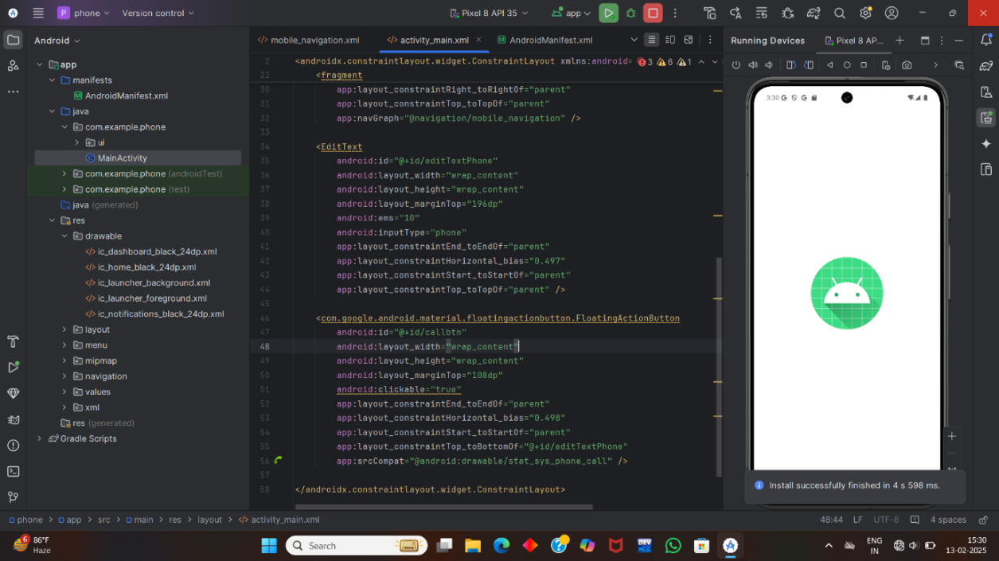
Step 5: Testing & Output
1.Test different functionalities of the app.
2.Capture the output results.
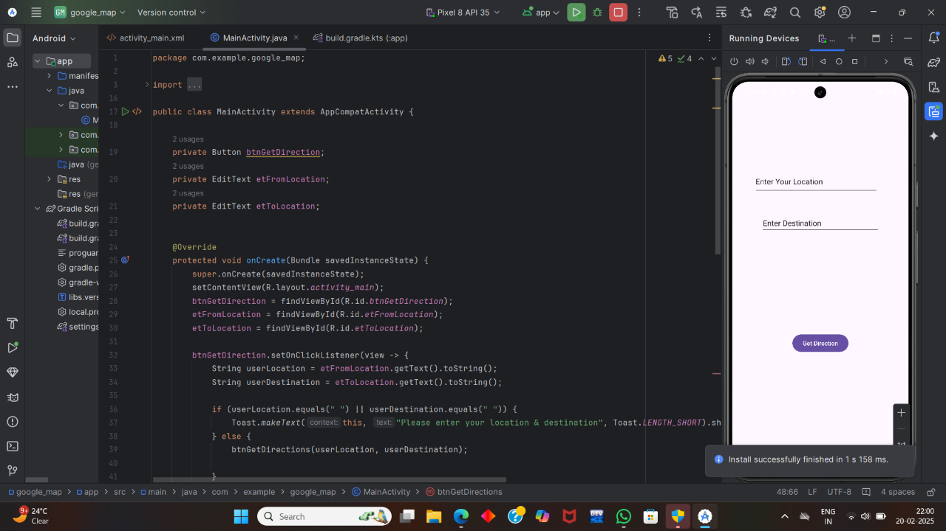
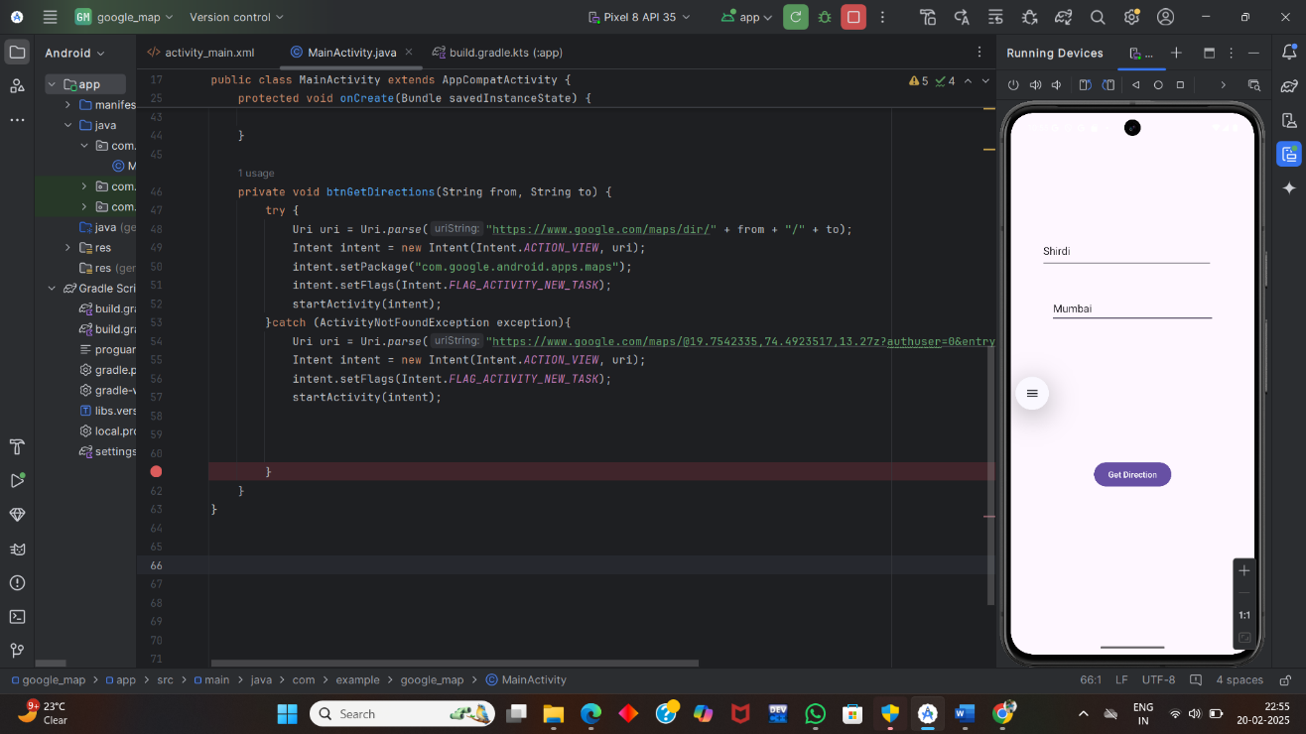
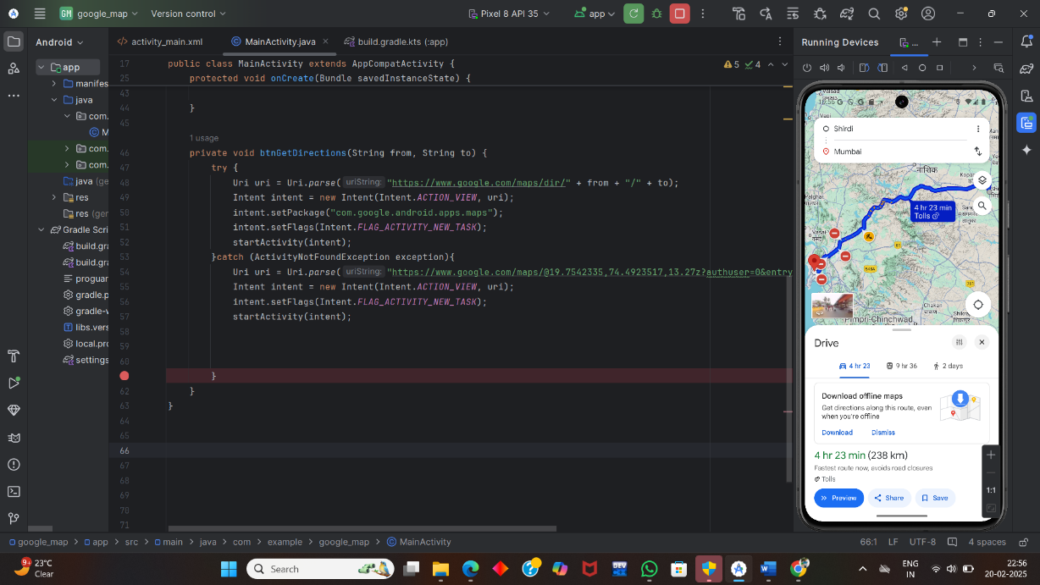
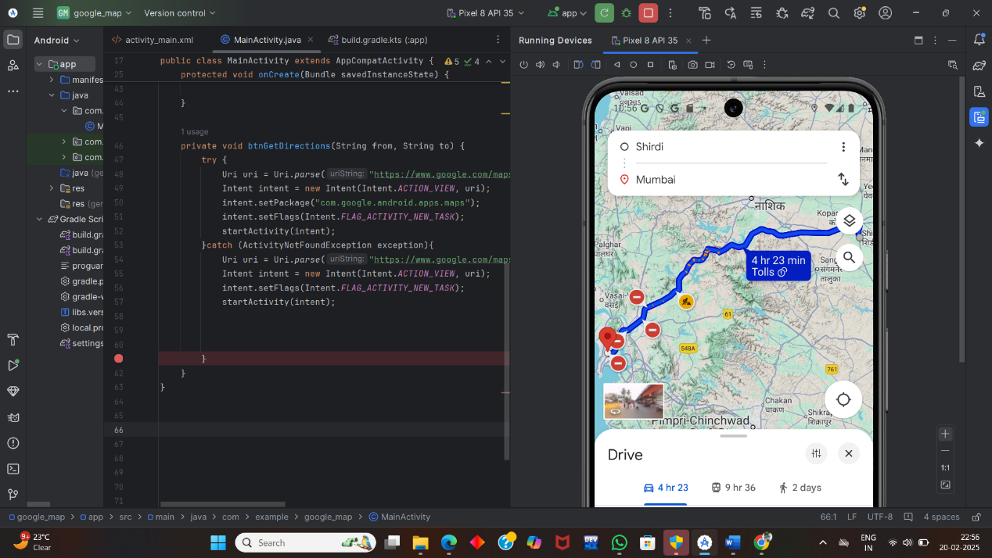

Step 6: Conclusion
I have Completed assignment Successfully of writing the code for that allows users to navigate from one application to another , I have demonstrated my understanding of user interface design principles and data registration process.

